**Module2 & Module3**

**Important Notes:**

* Whilst Module 1 is mostly for reference, Module2 and Module3 will run in your local machine
* Make sure they are both placed side by side in the same directory
* You need to make sure the following 3rd party packages are installed in your local python environment:

1. boto3
2. flask
3. joblib
4. markupsafe
5. matplotlib
6. pandas
7. scikit-learn

**Module2 Guide:**

1. In “A.ipynb” edit the variables shown below with your own credentials and save. You created these credentials when following the installation guide for “Module1”

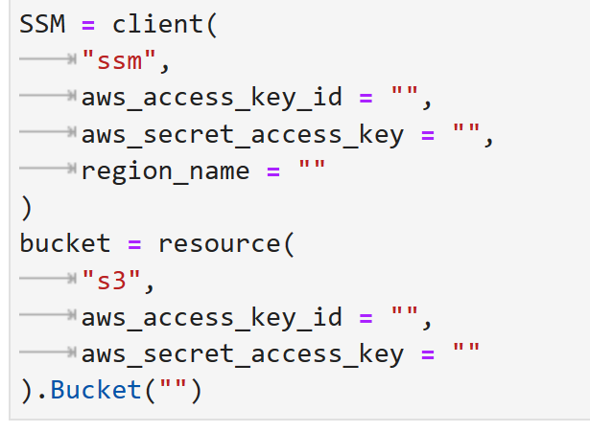

1. Make sure that next to the 4 ipynb files, you have 2 empty folders called “csv” and “data”
2. Run “A.ipynb”
3. When finished run “B.ipynb”
4. When finished run “C.ipynb”
5. When finished run “G.ipynb”

**Module3 Guide:**

1. Open command prompt inside the “Module3” folder
2. Run the command “python app.py”
3. In your default browser open link <http://127.0.0.1:5000> to open the flask app